**Lab 9 (additional): Global variables and the ball game**

Name......................................................ID....................................Section...............

In this additional lab, we shall develop a GUI program that simulates a moving ball and learn how to use global variables.

# 1. Timers and the moving “O”

In this section we will use **Timer** and develop a program that show the letter “O” moving. (This letter represents the moving ball in our game.)

We start by creating a new solution as Windows Applications. Then, click the **Design** tab, and increase the window size in the design panel. Add a **Label** into that window, change its **Text** property to “O”, and adjust its font so that it looks nice. (See Figure 1 (a).)

Then choose a **Timer** object from the **Tools** tab (usually at the end of the Window Forms category.) Its icon is shown in Figure 1(b). Drag the object to our design window; Figure 1(c) shows the result.

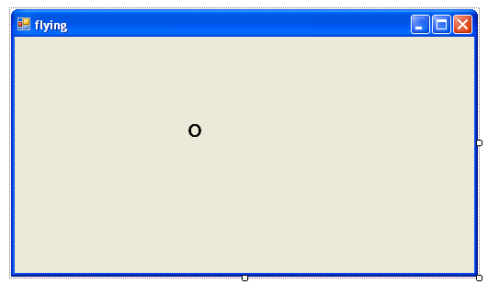  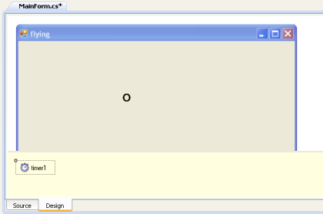

(a) (b) (c)

Figure 1 (a) the window after basic design, (b) the Timer icon, (c) the panel after placing the Timer object into the window

Timer **timer1** will be the main driver for our program. A timer will generate, at a fixed interval, events that drive our program. We can think of these objects as alarm clocks that keep ticking and wake up our program periodically.

We will enable **timer1** and write a program that moves the letter O to the right:

1. First, set the property **Enabled** of **timer1** to **True**, so that the timer starts working.

2. Double-click the timer1‘s icon (shown in Figure 1(c)) to edit its event handler. Sharp Dev will take us to method **Timer1Tick** as shown below. Change it to:

    void **Timer1Tick**(object sender, EventArgs e)  
    {  
      label1.Left += 1;  
    }

Run the program. We shall see that the letter “O” starts moving slowly to the right.

Answer the following questions:

|  |  |
| --- | --- |
| **Questions** | **Answer** |
| 1. How should we change the program so that the letter “O” move to the left? |  |
| 2. How should we modify the program so that the letter moves faster? |  |

# 2. Global variables

### 2.1 Velocity

Add a global variable **vx**, and change method **Timer1Tick** as shown below.

    static **int** vx = -10;  
    void **Timer1Tick**(object sender, EventArgs e)  
    {  
      label1.Left += vx;  
      vx++;  
    }

Run the program and observe how the letter “O” moves. Answer questions below.

|  |  |
| --- | --- |
| 1. Explain how the program works. Why does the letter O move that way? |  |
| 2. Suppose that we do not declare **vx** as a global variable, but instead we declare it as a local variable in method **Timer1Tick**. What would happen? |  |

### 2.2 A bouncing ball

We shall modify the program so that the letter O moves with constant speed to the left until it hits the left border and bounces back. Change method **Timer1Tick** to be as follows.

    void **Timer1Tick**(object sender, EventArgs e)  
    {  
      label1.Left += vx;  
      **if**(label1.Left < 0)  
        vx = 10;  
    }

Run the program. Note that the letter bounces when it hits the left border, but it does not do so when it hits the right border and it goes through the window and is gone.

Modify method **Timer1Tick** so that the letter O bounces when it hits the right border as well. Write down the method here:

    void **Timer1Tick**(object sender, EventArgs e)  
    {

    }

**Hint:** We can find the width of the window by looking at property **Size** in the **Properties** tab after clicking the window in the design panel.

### 2.3 Letter moving diagonally (bonus)

Modify the program so that the letter O moves diagonally and bounces when it hits any side border of the window. (Hint: **vy**) Write down all relevant code into the box below (including global variable declarations and method **Timer1Tick**) (You can use space at the back if needed.)